## India’s Agricultural Crops Production Analysis (1997-2021)

## Overview:

India is one of the major players in the agriculture sector worldwide and it is the primary source of livelihood for ~55% of India’s population.India has the world’s largest cattle herd (buffaloes), the largest area planted of wheat, rice, and cotton,and is the largest producer of milk,pulses,and spices in the world.It is the second-largest producer of fruits, vegetables, tea, farmed fish, cotton, sugarcane, wheat, rice. The agriculture sector in India holds the record for second-largest agricultural land in the world generating employment for about half of the country’s population.Thus,farmers become an integral part of the sector to provides us with a means of sustenance.

## Purpose:

* To enhance the economic development of all stake-holders.
* To generate employment in order to combat vagaries of unemployment problem.
* To enhance the per capital income to minimize the difference between rural and urban.
* To improve nutritional standards for betterment of health.
* To create marketing facilities to reduce post-harvest loss and distress sale of agriculture produce.

## Problem definition & Design thinking

## Empathy Map

## Annotation 2023-10-14 094821

## Ideation and Brainstorming map

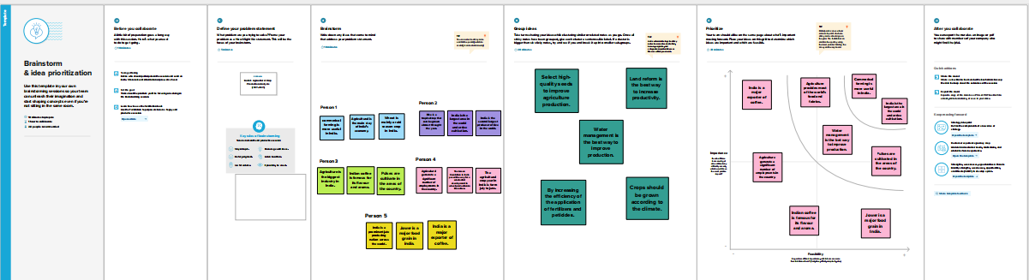

## Results:

Agriculture and allied sectors like animal husbandry, forestry, and fisheries accounted for 17.5% of the GDP with about 41.49% of the workforce in 2020.India ranks first in the world with highest net cropped area followed by US and China.The economic contribution of agriculture to India’s GDP is steadily declining with the country’s broad-based economic growth.Still, agriculture is demographically the broadest economic sector and plays a significant role in the overall socio-economic fabric of India.

## Advantages:

* In India, the agriculture sector has more than half of the total population of the country engaged, which makes it the sector with the most number of employees in the country.
* India is the second-most populous country in the world. And to feed such a huge population,there is always a constant need for a supply of food.
* In India, around half of the income generated in the industrial sector comes from agricultural-based industries. Therefore, in India, the industrial sector is highly dependent on the agricultural sector.
* Indian agriculture is important for the industrial sector and trading purposes both internally and externally.
* Agriculture is the most significant source of income for the central and state governments.

## Disadvantages:

* Over-dependence on unreliable rain and lack of irrigation facilities has led to a decline in agricultural output.
* Poverty and illiteracy of the farmers prevent them from making large-scale capital investments and adopting scientific methods of cultivation.
* Small land holdings due to fast-growing population which leads to fragmentation of land at quick succession.
* Erosion of soil by heavy rain, floods, insufficient vegetation cover etc.., reduces farm productivity.
* Inadequate irrigation facilities and poor management of water resources have led to a great decline in agricultural productivity.

## Application:

* Smart sensors: Many types of sensors are available today.There are tools for estimating the state of soil and vital factors, detecting signs of infestation and disease, estimating humidity and temperature, as well as monitoring lighting conditions.
* Software: Software solutions help to transfer, process, accumulate and organize data received from sensors.
* Robotics: Modern farming greatly relies on various pieces of equipment and machinery, and thanks to cutting -edge technologies, it is possible to apply them more efficiently.

## Conclusion:

Agriculture is an important sector of the country. It is one of the market-driven industries that employ a large segment of the country’s population . The new changes over the last few years have been enormously helpful to contribute more towards economic growth. It has been supporting farmers to increase productivity and contribute more towards the agricultural economy.

## Future Scope:

* Changing demand due to increase in incomes, globalization and health consciousness is affecting and going to affect more the production in future.
* Researches, technology improvements, protected cultivation of high value greens and other vegetables will be more.
* Use of biotechnology and breeding will be very important in developing eco-friendly and disease resistant, climate resilient, more nutritious and tastier crop varieties.
* Precision farming with soil testing -based decisions, automation using artificial intelligence will be focused for precise application inputs in agriculture.